UNIT III
Bayesian Learning:
Features of Bayesian learning methods include:
- Each observed training example can incrementally decrease or increase the estimated probability that a hypothesis is correct
- Prior knowledge can be combined with observed data to determine the final probability of a hypothesis
- Bayesian methods can accommodate hypotheses that make probabilistic predictions
- New instances can be classified by combining the predictions of multiple hypotheses, weighted by their probabilities.
- Bayesian methods can provide a standard of optimal decision making against which other practical methods can be measured.
One practical difficulty in applying Bayesian methods is that they typically require initial knowledge of many probabilities. When these probabilities are not known in advance they are often estimated based on background knowledge, previously available data, and assumptions about the form of the underlying distributions.
Bayes Theorem
Bayes theorem is the cornerstone of Bayesian learning methods because it provides a way to calculate the posterior probability P(h/D), from the prior probability P(h), together with P(D) and P(D/h).
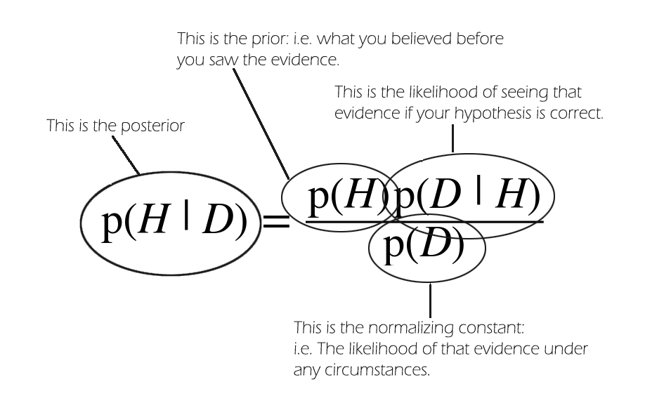
As one might intuitively expect, P(h/D) increases with P(h) and with P(D/h) according to Bayes theorem.

Definitions
A prior probability is an initial probability value originally obtained before any additional information is obtained.
A posterior probability is a probability value that has been revised by using additional information that is later obtained.
Example
An aircraft emergency locator transmitter (ELT) is a device designed to transmit a signal in the case of a crash. The Altigauge Manufacturing Company makes 80% of the ELTs, the Bryant Company makes 15% of them, and the Chartair Company makes the other 5%. The ELTs made by Altigauge have a 4% rate of defects, the Bryant ELTs have a 6% rate of defects, and the Chartair ELTs have a 9% rate of defects (which helps to explain why Chartair has the lowest market share). a. If an ELT is randomly selected from the general population of all ELTs, find the probability that it was made by the Altigauge Manufacturing Company. b. If a randomly selected ELT is then tested and is found to be defective, find the probability that it was made by the Altigauge Manufacturing Company.

Solution
We use the following notation:
A = ELT manufactured by Altigauge
B = ELT manufactured by Bryant
C = ELT manufactured by Chartair
D = ELT is defective
D’ = ELT is not defective (or it is good)
a. If an ELT is randomly selected from the general population of all ELTs, the probability that it was made by Altigauge is 0.8 (because Altigauge manufactures 80% of them).
b. If we now have the additional information that the ELT was tested and was found to be defective, we want to revise the probability from part (a) so that the new information can be used. We want to find the value of P(A|D), which is the probability that the ELT was made by the Altigauge company given that it is defective. Based on the given information, we know these probabilities:
P(A) = 0.80 because Altigauge makes 80% of the ELTs
P(B) = 0.15 because Bryant makes 15% of the ELTs
P(C) = 0.05 because Chartair makes 5% of the ELTs
P(D|A) = 0.04 because 4% of the Altigauge ELTs are defective
P(D|B) = 0.06 because 6% of the Bryant ELTs are defective
P(D|C) = 0.09 because 9% of the Chartair ELTs are defective
Here is Bayes' theorem extended to include three events corresponding to the selection of ELTs from the three manufacturers (A, B, C):
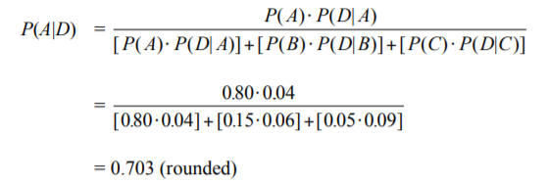

Optimal Bayes Classifier
The Optimal Bayes classifier chooses the class that has greatest a posteriori probability of occurrence (so called maximum a posteriori estimation, or MAP). It can be shown that of all classifiers, the Optimal Bayes classifier is the one that will have the lowest probability of miss classifying an observation, i.e. the lowest probability of error. So if we know the posterior distribution, then using the Bayes classifier is as good as it gets.
In real-life we usually do not know the posterior distribution, but rather we estimate it. The Naive Bayes classifier approximates the optimal Bayes classifier by looking at the empirical distribution and by assuming independence of predictors. So the Naive Bayes classifier is not itself optimal, but it approximates the optimal solution.
To develop some intuitions consider a hypothesis space containing three hypotheses, hl, h2, and h3. Suppose that the posterior probabilities of these hypotheses given the training data are .4, .3, and .3 respectively. Thus, hl is the MAP hypothesis. Suppose a new instance x is encountered, which is classified positive by hl, but negative by h2 and h3. Taking all hypotheses into account, the probability that x is positive is .4 (the probability associated with hi), and the probability that it is negative is therefore .6. The most probable classification (negative) in this case is different from the classification generated by the MAP hypothesis.
In general, the most probable classification of the new instance is obtained by combining the predictions of all hypotheses, weighted by their posterior probabilities. If the possible classification of the new example can take on any value vj from some set V, then the probability P(vjlD) that the correct classification for the new instance is v;, is just
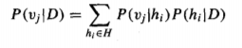
The optimal classification of the new instance is the value v,, for which P (v; 1 D) is maximum.
Bayes optimal classification:
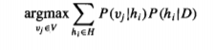
To illustrate in terms of the above example, the set of possible classifications of the new instance is and
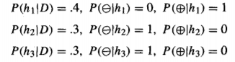
therefore
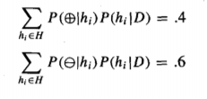
and
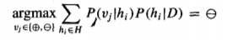

Principle of Naive Bayes Classifier:
A Naive Bayes classifier is a probabilistic machine learning model that’s used for classification task. The crux of the classifier is based on the Bayes theorem.

Bayes Theorem:

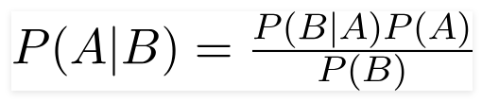
Using Bayes theorem, we can find the probability of A happening, given that B has occurred. Here, B is the evidence and A is the hypothesis. The assumption made here is that the predictors/features are independent. That is presence of one particular feature does not affect the other. Hence it is called naive.

Example:
Say you have 1000 fruits which could be either ‘banana’, ‘orange’ or ‘other’. These are the 3 possible classes of the Y variable.
We have data for the following X variables, all of which are binary (1 or 0).
- Long
- Sweet
- Yellow
The first few rows of the training dataset look like this:
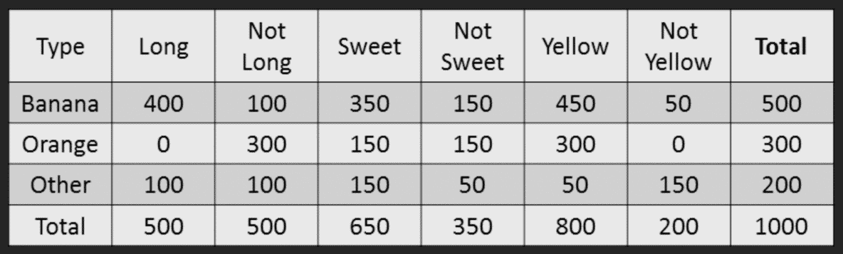

So the objective of the classifier is to predict if a given fruit is a ‘Banana’ or ‘Orange’ or ‘Other’ when only the 3 features (long, sweet and yellow) are known.
Let’s say you are given a fruit that is: Long, Sweet and Yellow, can you predict what fruit it is?
This is the same of predicting the Y when only the X variables in testing data are known. Let’s solve it by hand using Naive Bayes.
The idea is to compute the 3 probabilities, that is the probability of the fruit being a banana, orange or other. Whichever fruit type gets the highest probability wins.
All the information to calculate these probabilities is present in the above tabulation.
Step 1: Compute the ‘Prior’ probabilities for each of the class of fruits.
That is, the proportion of each fruit class out of all the fruits from the population. You can provide the ‘Priors’ from prior information about the population. Otherwise, it can be computed from the training data.
For this case, let’s compute from the training data. Out of 1000 records in training data, you have 500 Bananas, 300 Oranges and 200 Others. So the respective priors are 0.5, 0.3 and 0.2.
P(Y=Banana) = 500 / 1000 = 0.50
P(Y=Orange) = 300 / 1000 = 0.30
P(Y=Other) = 200 / 1000 = 0.20
Step 2: Compute the probability of evidence that goes in the denominator.
This is nothing but the product of P of Xs for all X. This is an optional step because the denominator is the same for all the classes and so will not affect the probabilities.
P(x1=Long) = 500 / 1000 = 0.50
P(x2=Sweet) = 650 / 1000 = 0.65
P(x3=Yellow) = 800 / 1000 = 0.80
Step 3: Compute the probability of likelihood of evidences that goes in the numerator.
It is the product of conditional probabilities of the 3 features. If you refer back to the formula, it says P(X1 |Y=k). Here X1 is ‘Long’ and k is ‘Banana’. That means the probability the fruit is ‘Long’ given that it is a Banana. In the above table, you have 500 Bananas. Out of that 400 is long. So, P(Long | Banana) = 400/500 = 0.8.
Here, I have done it for Banana alone.
Probability of Likelihood for Banana
P(x1=Long | Y=Banana) = 400 / 500 = 0.80
P(x2=Sweet | Y=Banana) = 350 / 500 = 0.70
P(x3=Yellow | Y=Banana) = 450 / 500 = 0.90
So, the overall probability of Likelihood of evidence for Banana = 0.8 * 0.7 * 0.9 = 0.504
Step 4: Substitute all the 3 equations into the Naive Bayes formula, to get the probability that it is a banana.
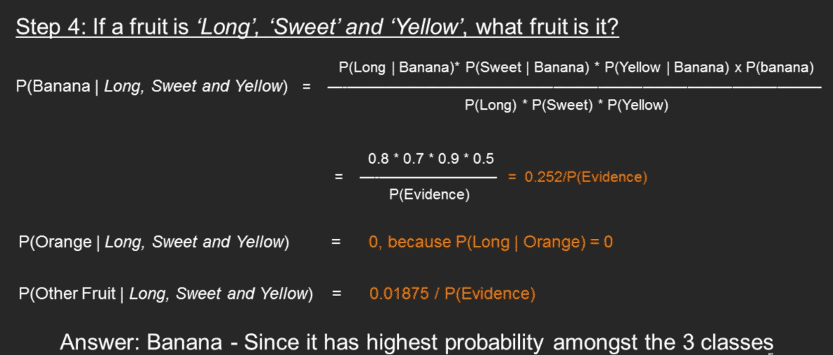

Hidden Markov Models

Overview
Hidden Markov Models (HMMs) are a class of probabilistic graphical model that allow us to predict a sequence of unknown (hidden) variables from a set of observed variables. A simple example of an HMM is predicting the weather (hidden variable) based on the type of clothes that someone wears (observed). An HMM can be viewed as a Bayes Net unrolled through time with observations made at a sequence of time steps being used to predict the best sequence of hidden states.
The below diagram from Wikipedia shows an HMM and its transitions. The scenario is a room that contains urns X1, X2 and X3, each of which contains a known mix of balls, each ball labelled y1, y2, y3 and y4. A sequence of four balls is randomly drawn. In this particular case, the user observes a sequence of balls y1,y2,y3 and y4 and is attempting to discern the hidden state which is the right sequence of three urns that these four balls were pulled from.

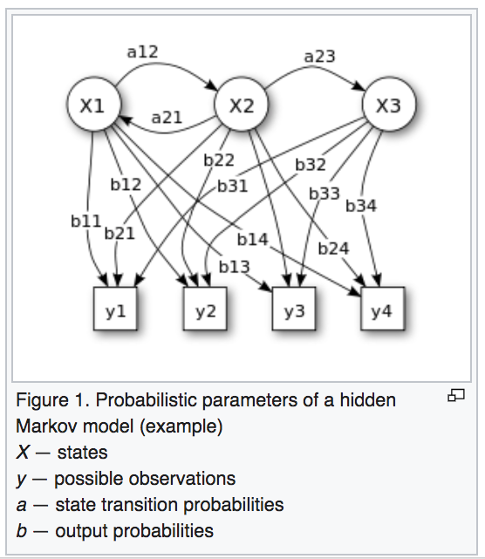
Figure 1: HMM hidden and observed states

Why Hidden, Markov Model?
The reason it is called a Hidden Markov Model is because we are constructing an inference model based on the assumptions of a Markov process. The Markov process assumption is simply that the “future is independent of the past given the present”. In other words, assuming we know our present state, we do not need any other historical information to predict the future state.
To make this point clear, let us consider the scenario below where the weather, the hidden variable, can be hot, mild or cold and the observed variables are the type of clothing worn. The arrows represent transitions from a hidden state to another hidden state or from a hidden state to an observed variable.
Notice that, true to the Markov assumption, each state only depends on the previous state and not on any other prior states.

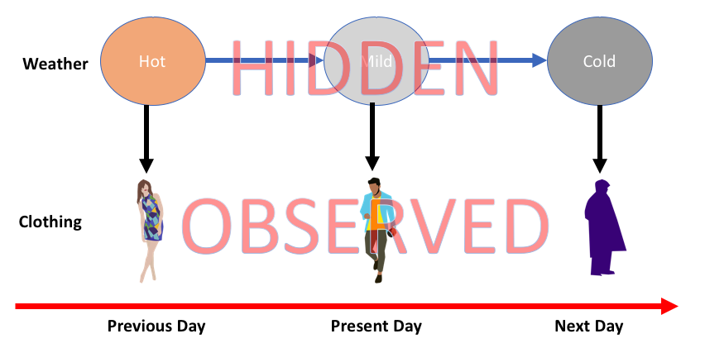
Figure 2: HMM State Transitions

Intuition behind HMMs
HMMs are probabilistic models. They allow us to compute the joint probability of a set of hidden states given a set of observed states. The hidden states are also referred to as latent states. Once we know the joint probability of a sequence of hidden states, we determine the best possible sequence i.e. the sequence with the highest probability and choose that sequence as the best sequence of hidden states.
The ratio of hidden states to observed states is not necessarily 1 is to 1 as is evidenced by Figure 1 above. The key idea is that one or more observations allow us to make an inference about a sequence of hidden states.
In order to compute the joint probability of a sequence of hidden states, we need to assemble three types of information.
Generally, the term “states” are used to refer to the hidden states and “observations” are used to refer to the observed states.

- Transition data — the probability of transitioning to a new state conditioned on a present state.
- Emission data — the probability of transitioning to an observed state conditioned on a hidden state.
- Initial state information — the initial probability of transitioning to a hidden state. This can also be looked at as the prior probability.
The above information can be computed directly from our training data. For example, in the case of our weather example in Figure 2, our training data would consist of the hidden state and observations for a number of days. We could build our transition matrices of transitions, emissions and initial state probabilities directly from this training data.

The example tables show a set of possible values that could be derived for the weather/clothing scenario.
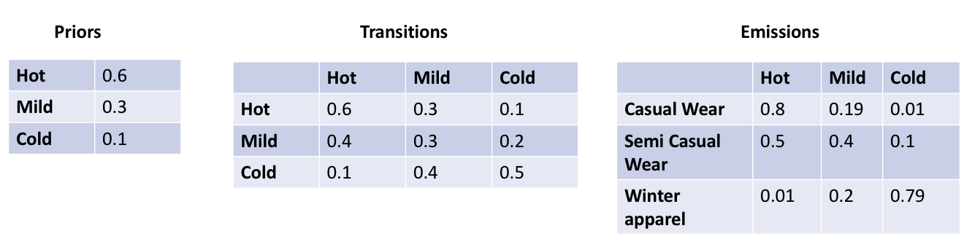
Figure 3: HMM State Transitions — Weather Example
Once this information is known, then the joint probability of the sequence, by the conditional probability chain rule and by Markov assumption, can be shown to be proportional to P(Y) below

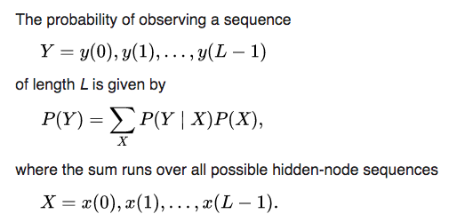
Figure 4: HMM — Basic Math

Note that as the number of observed states and hidden states gets large the computation gets more computationally intractable. If there are k possible values for each hidden sequence and we have a sequence length of n, there are n^k total possible sequences that must be all scored and ranked in order to determine a winning candidate.

Variations of the Hidden Markov Model — HMM EM
The probability distributions of hidden states is not always known. In this case, we use Expectation Maximization (EM) models in order to determine hidden state distributions. A popular algorithm is the Baum-Welch algorithm

UNIT IV
Evolutionary Learning
Genetic Algorithm:
The Genetic Algorithm is a computational approximation to how evolution performs search, which is done by producing modifications of the parent genomes in their off.spring and thus producing new individuals with different fitness
To formalize a definition of a genetic algorithm, we can say that it is an optimization technique, which tries to find out such values of input so that we get the best output values or results.
Things that we need to model simple genetics inside a computer and solve problems with it are:
• a method for representing problems as chromosomes
• a way to calculate the fitness of a solution
• a selection method to choose parents
• a way to generate offspring by breeding the parents

String Representation
In analogy to the chromosome, individual solutions of GAs are represented as a string, with each element of the string (equivalent to the gene) being chosen from some binary alphabet. The different values in the alphabet, are analogous to the variations. For the problem we are trying to solve we have to work out a way of encoding the description of a solution as a string.

We then create a set of random strings to be our initial population

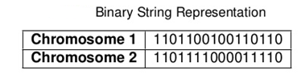

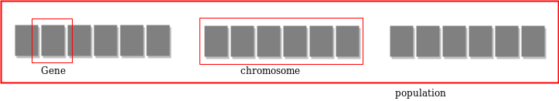

chromosomes are binary strings, and generally a 1 would mean that the corresponding item (gene in biology) is taken and 0 meaning that it is dropped. We then encode a solution using 0 for the things we will not take and 1 for the things we will. So if there were four things we wanted to take, then (0, 1, 1, 0) would mean that we take the middle two, but not the first or last.

Steps Involved in Genetic Algorithm
- Initialisation
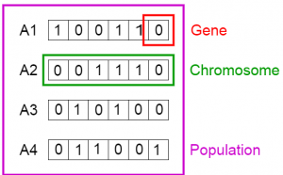
This set of chromosomes is considered as our initial population.
- Evaluating Fitness
The fitness function can be seen as an oracle that takes a string as an argument and returns
a value for that string.
what we want from our fitness function? Clearly, the best string should have the highest fitness, and the fitness should decrease as the strings do less well on the problem.

- Population
The GA works on a population of strings, with the first generation usually being created randomly. The fitness of each string is then evaluated, and that first generation is bred together to make a second generation, which is then used to generate a third, and so on.
- Generating Offspring: Parent Selection
We now need to choose parents out of this population, and start breeding them. For the current generation we need to select those strings that will be used to generate new offspring. The idea here is that average fitness will improve if we select strings that are already relatively fit compared to the other members of the population (following natural selection), which is exploitation of our current population.

Genetic Operators:

1.Crossover
Once the parents parent chromosomes are selected that will produce off-springs Crossover operation is performed. crossover is nothing but reproduction.
Take a look at the image below. On the left side are the Parent Chromosomes and off-springs are on the right side.
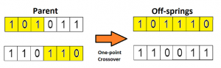
This is the most basic form of crossover, known as one point crossover. Here we select a random crossover point and the tails of both the chromosomes are swapped to produce a new off-springs.
If you take two crossover point, then it will called as multi point crossover which is as shown below.
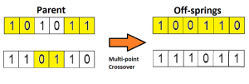

2. Mutation
Now, thinking in the biological sense, the children do not have the same traits as their parents. During their growth, there is some change in the genes of children which makes them different from its parents.
This process is known as mutation, which may be defined as a random tweak in the chromosome, which also promotes the idea of diversity in the population.
A simple method of mutation is shown in the image below.
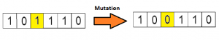
The entire process is summarised as shown in the figure below.
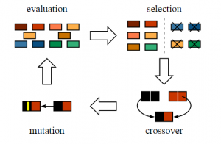

The Basic Genetic Algorithm

• Initialisation
– generate N random strings of length L with the chosen alphabet
• Learning
– repeat:
* create an (initially empty) new population
* repeat:
· select two strings from current population, preferably using fitness proportional
selection
· recombine them in pairs to produce two new strings
· mutate the offspring
· either add the two offspring to the p
opulation, or use tournaments to put
two strings from the four of parents and offspring into the population
* until N strings for the new population are generated
* optionally, use elitism to take the fittest strings from the parent generation
and replace some others from the child generation

Genetic Programming

The basic idea of Genetic Programming is to represent a computer program as a tree. Tree-based variants on mutation and crossover are defined (replace subtrees by other subtrees, either randomly generated (mutation) or swapped from another tree (crossover), and then the genetic program runs just like a normal genetic algorithm, but acting on these program trees rather than strings.
Genetic programming has been used for many different tasks, from recognising skin melanomas to circuit design, and lots of very impressive results have been claimed for it. However, the search space is unbelievably large, and the mutation operator not especially usually chosen by the system developer first in order to give the system a head start.

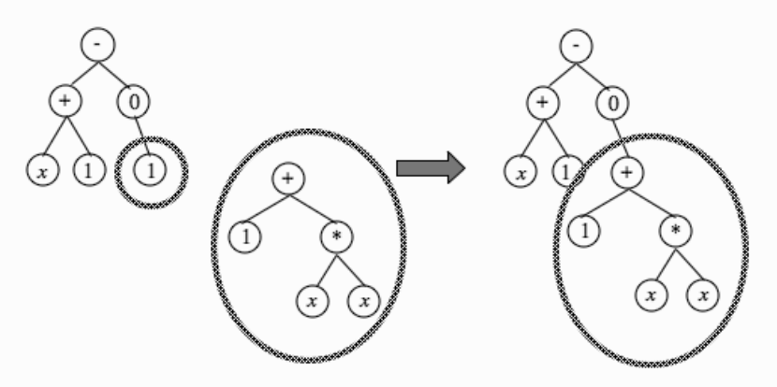

Fig 1:Example of a mutation in genetic programming.

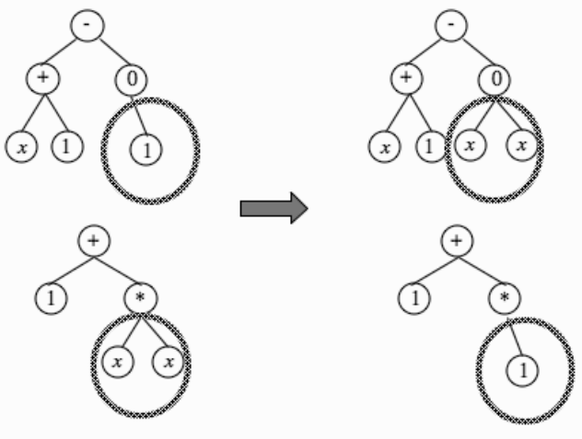

Fig 2:Example of a crossover in genetic programming

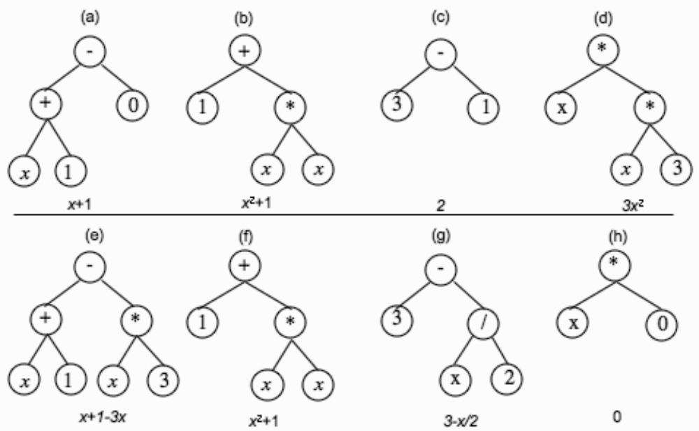
Top: Four arithmetical trees. Bottom: Example developments of the four trees: (e) and (h) are a possible crossover of (a) and (d), (f) is a copy of (b), and (g) is a mutation of (c).

Ensemble Learning

Ensemble learning helps improve machine learning results by combining several models. This approach allows the production of better predictive performance compared to a single model.

Ensemble methods are meta-algorithms that combine several machine learning techniques into one predictive model in order to decrease variance , bias (boosting), or improve predictions (stacking).

Types of Ensemble Methods
- BAGGing, or Bootstrap AGGregating. BAGGing gets its name because it combines Bootstrapping and Aggregation to form one ensemble model. Given a sample of data, multiple bootstrapped subsamples are pulled. A Decision Tree is formed on each of the bootstrapped subsamples. After each subsample Decision Tree has been formed, an algorithm is used to aggregate over the Decision Trees to form the most efficient predictor. The figure below explains this more clearly:

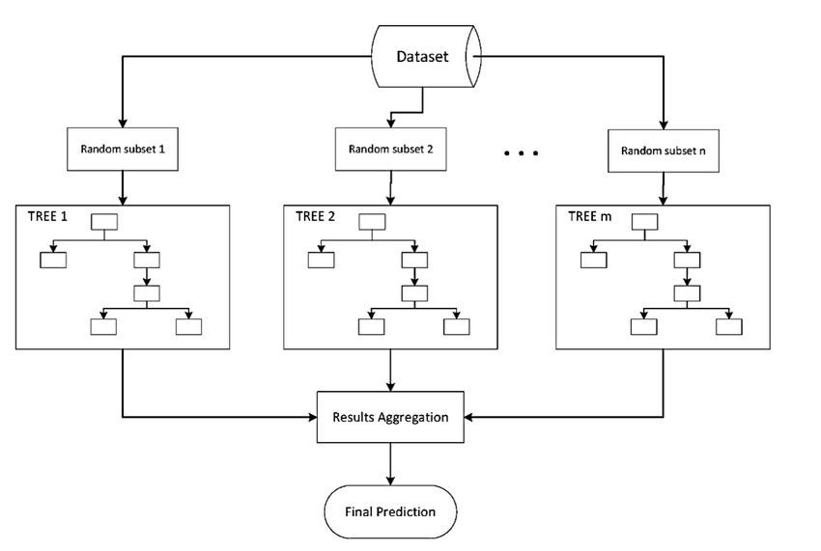

2.Boosting
Boosting refers to a family of algorithms that are able to convert weak learners to strong learners. The main principle of boosting is to fit a sequence of weak learners− models that are only slightly better than random guessing, such as small decision trees− to weighted versions of the data. More weight is given to examples that were misclassified by earlier rounds.
The predictions are then combined through a weighted majority vote (classification) or a weighted sum (regression) to produce the final prediction. The principal difference between boosting and bagging is that base learners are trained in sequence on a weighted version of the data.

If a data point is incorrectly predicted by the first model, and then the next (probably all models), will combining the predictions provide better results? Such situations are taken care of by boosting.
Boosting is a sequential process, where each subsequent model attempts to correct the errors of the previous model. The succeeding models are dependent on the previous model. Let’s understand the way boosting works in the below steps.
- A subset is created from the original dataset.
- Initially, all data points are given equal weights.
- A base model is created on this subset.
- This model is used to make predictions on the whole dataset.
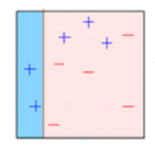
5.Errors are calculated using the actual values and predicted values.
6.The observations which are incorrectly predicted, are given higher weights.
(Here, the three misclassified blue-plus points will be given higher weights)
7.Another model is created and predictions are made on the dataset.
(This model tries to correct the errors from the previous model)
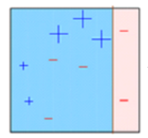
8.Similarly, multiple models are created, each correcting the errors of the previous model.
9.The final model (strong learner) is the weighted mean of all the models (weak learners).
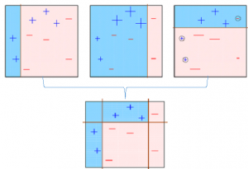
Thus, the boosting algorithm combines a number of weak learners to form a strong learner. The individual models would not perform well on the entire dataset, but they work well for some part of the dataset. Thus, each model actually boosts the performance of the ensemble.
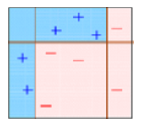
Dimensionality Reduction

What is Dimensionality Reduction?
Dimensionality reduction is simply, the process of reducing the dimension of your feature set. Your feature set could be a dataset with a hundred columns (i.e features) or it could be an array of points that make up a large sphere in the three-dimensional space. Dimensionality reduction is bringing the number of columns down to say, twenty or converting the sphere to a circle in the two-dimensional space.
Avoiding overfitting is a major motivation for performing dimensionality reduction. The fewer features our training data has, the lesser assumptions our model makes and the simpler it will be.

Dimensionality Reduction Methods
1.LDA (Linear Discriminant Analysis): projects data in a way that the class separability is maximised. Examples from same class are put closely together by the projection. Examples from different classes are placed far apart by the projection.
2.PCA (Principal Component Analysis): Popularly used for dimensionality reduction in continuous data, PCA rotates and projects data along the direction of increasing variance. The features with the maximum variance are the principal components.
Linear Discriminant Analysis:
The goal of Linear Discriminant Analysis is to project the features in higher dimension space onto a lower dimensional space.
This can be achieved in three steps:
The first step is to calculate the separability between different classes (i.e the distance between the mean of different classes) also called as between-class variance

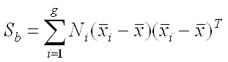
Second Step is to calculate the distance between the mean and sample of each class, which is called the within class variance

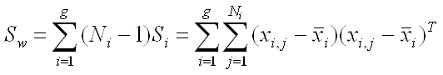
The third step is to construct the lower dimensional space which maximizes the between class variance and minimizes the within class variance. Let P be the lower dimensional space projection, which is called Fisher’s criterion.

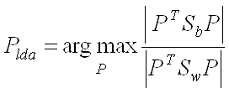

Principal Component Analysis:
PCA finds a new set of dimensions (or a set of basis of views) such that all the dimensions are orthogonal (and hence linearly independent) and ranked according to the variance of data along them. It means more important principle
axis occurs first. (more important = more variance/more spread out data)
How does PCA work -
- Calculate the covariance matrix X of data points.
- Calculate eigen vectors and corresponding eigen values.
- Sort the eigen vectors according to their eigen values in decreasing order.
- Choose first k eigen vectors and that will be the new k dimensions.
- Transform the original n dimensional data points into k dimensions.

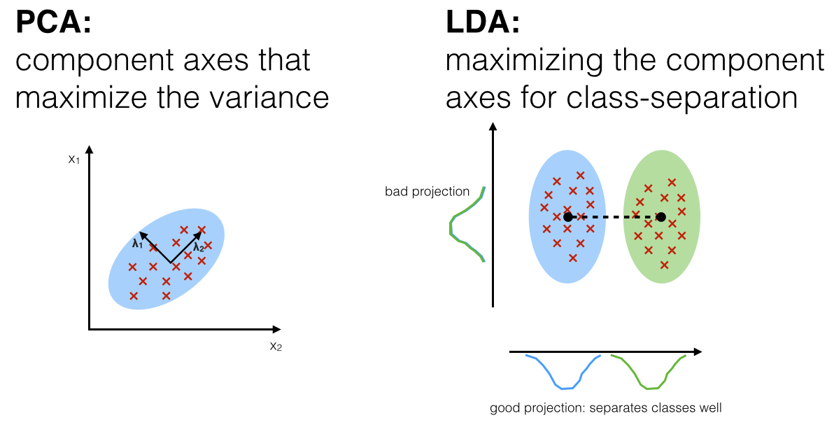
UNIT V

Cluster analysis or simply clustering is the process of partitioning a set of data objects (or observations) into subsets. Each subset is a cluster, such that objects in a cluster are similar to one another, yet dissimilar to objects in other clusters. The set of clusters resulting from a cluster analysis can be referred to as a clustering.

Cluster analysis has been widely used in many applications such as business intelligence, image pattern recognition, Web search, biology, and security.
In machine learning, recall that classification is known as supervised learning because the class label information is given. Clustering is known as unsupervised learning because the class label information is not present. For this reason, clustering is a form of learning by observation, rather than learning by examples

Similarity and Distance Measures:
Dissimilarity or “difference” between objects i and j is a non-negative number that is close to 0 when objects i and j are highly similar or “near” each other, and becomes larger the more they differ. The difference between an object and itself is 0.
Measures of similarity can often be expressed as a function of measures of dissimilarity.
Sim(i, j)= 1-d(i, j)

where Sim(i, j)is the similarity between objects i and j and d(i,j) is the dissimilarity between objects.

Distance or similarity measures are essential in solving many pattern recognition problems such as classification and clustering. Various distance/similarity measures are available in the literature to compare two data distributions. As the names suggest, a similarity measures how close two distributions are. For multivariate data complex summary methods are developed to answer this question.
Similarity Measure
Numerical measure of how alike two data objects are. Often fall between 0 (no similarity) and 1 (complete similarity)
Dissimilarity Measure
Numerical measure of how different two data objects are range from 0 (objects are alike) to ∞ (objects are different)
Proximity
refers to a similarity or dissimilarity

Similarity/Dissimilarity for Simple Attributes
Here, p and q are the attribute values for two data objects.
Distance, such as the Euclidean distance, is a dissimilarity measure and has some well-known properties: Common Properties of Dissimilarity Measures
- d(p, q) ≥ 0 for all p and q, and d(p, q) = 0 if and only if p = q,
- d(p, q) = d(q,p) for all p and q,
- d(p, r) ≤ d(p, q) + d(q, r) for all p, q, and r, where d(p, q) is the distance (dissimilarity) between points (data objects), p and q.
A distance that satisfies these properties is called a metric. Following is a list of several common distance measures to compare multivariate data. We will assume that the attributes are all continuous.

Distance measures for numeric data points

Minkowski Distance:
It is a generic distance metric where Manhattan(r=1) or Euclidean(r=2) distance measures are generalizations of it.
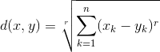

Manhattan Distance:
It is the sum of absolute differences between the coordinates. It is also called as Rectilinear Distance, L1-Distance/L1-Norm, Minkowski’s L1 Distance, City Block Distance, Taxi Cab Distance.

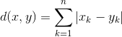

Euclidean Distance:
It is the square-root of sum of squares of difference between the coordinates and is given by Pythagorean theorem. Also called as L2 Norm, Ruler Distance. In general, default distance is considered as Euclidean distance.

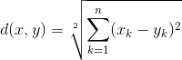
Use Manhattan or Euclidean distance measures if there are no missing values in the training data set (data is dense)

Cosine Similarity
This measures the cosine of angle between two data points (instances). It is a judgment of orientation rather than magnitude between two instances/vectors with respect to the origin. The cosine of 0degrees is 1 which means the data points are similar and cosine of 90degrees is 0 which means data points are dissimilar (all these angular measures are independent of magnitude).
- Mostly used in high dimensional positive spaces where output is bounded in the range of [0,1].
- Used in Information Retrieval, Text Mining, Recommendation Systems and Classifications. It is also used to measure cohesion between the clusters in Data Mining.
- It is very efficient to evaluate sparse vectors(as only the non-zero dimensions in the space are considered)
- If the attribute vectors are normalized by subtracting the vector means [e.g., Ai – mean(A)], the measure is called centered cosine similarity and is equivalent to the Pearson Correlation Coefficient.
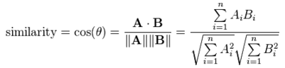

Disadvantage: Cosine similarity is subjective to the domain and application and is not an actual distance metric. For example data points [1,2] and [100,200], are shown similar with cosine similarity, whereas in eucildean distance measure shows they are far away from each other (in a way not similar).

Pearson Correlation Coefficient

This is a measure of correlation between two random variables. It ranges between [-1, 1]. 1 is the perfect agreement and -1 is perfect disagreement. We use this when we have grade inflation problem.

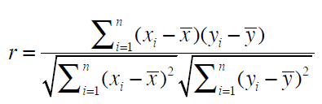

Jaccard Similarity
Data points in Jaccard Similarity are sets rather than vectors. Sometimes the equality of certain values does not mean anything and this problem is addressed with Jaccard Similarity.
For any two sets A and B,
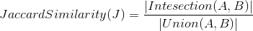

Outliers:

Outliers are extreme values that deviate from other observations on data , they may indicate a variability in a measurement or experimental errors.
Most common causes of outliers on a data set:
- Data entry errors (human errors)
- Measurement errors (instrument errors)
- Experimental errors (data extraction or experiment planning/executing errors)
- Intentional (dummy outliers made to test detection methods)
- Data processing errors (data manipulation or data set unintended mutations)
- Sampling errors (extracting or mixing data from wrong or various sources)
- Natural (not an error, novelties in data)

Basic Clustering Methods

Partitioning methods:
Given a set of n objects, a partitioning method constructs k partitions of the data, where each partition represents a cluster and k _ n. That is, it divides the data into k groups such that each group must contain at least one object. The basic partitioning methods typically adopt exclusive cluster separation. That is, each object must belong to exactly one group.
Most partitioning methods are distance-based. Given k, the number of partitions to construct, a partitioning method creates an initial partitioning. It then uses an iterative relocation technique that attempts to improve the partitioning by moving objects from one group to another. The general criterion of a good partitioning is
that objects in the same cluster are “close” or related to each other, whereas objects in different clusters are “far apart” or very different.

Hierarchical methods:
A hierarchical method creates a hierarchical decomposition of the given set of data objects. A hierarchical method can be classified as being either agglomerative or divisive, based on how the hierarchical decomposition is formed.
The agglomerative approach, also called the bottom-up approach, starts with each object forming a separate group. It successively merges the objects or groups close to one another, until all the groups are merged into one (the topmost level of the hierarchy), or a termination condition holds.
The divisive approach, also called the top-down approach, starts with all the objects in the same cluster. In each successive iteration, a cluster is split into smaller clusters, until eventually each object is in one cluster, or a termination condition holds.
Hierarchical methods suffer from the fact that once a step (merge or split) is done, it can never be undone.

Method | General Characteristics
Partitioning methods | --Find mutually exclusive clusters of spherical shape  – Distance-based  – May use mean or medoid (etc.) to represent cluster center  – Effective for small- to medium-size data sets
Hierarchical methods | -Clustering is a hierarchical decomposition (i.e., multiple levels)  – Cannot correct erroneous merges or splits  – May incorporate other techniques like microclustering or  consider object “linkages”

Partitioning methods:
k-Means: A Centroid-Based Technique
A centroid-based partitioning technique uses the centroid of a cluster, Ci , to represent that cluster. Conceptually, the centroid of a cluster is its center point. The centroid can be defined in various ways such as by the mean or medoid of the objects (or points)assigned to the cluster. The difference between an object p 2 Ci and ci, the representative of the cluster, is measured by dist(p, ci), where dist(x,y) is the Euclidean distance
between two points x and y.

The quality of cluster Ci can be measured by the within cluster variation, which is the sum of squared error between all objects in Ci and the centroid ci, defined as:

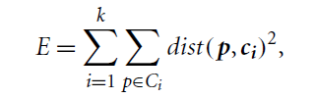

Working of k-means algorithm:
The k-means algorithm defines the centroid of a cluster as the mean value of the points within the cluster. It proceeds as follows. First,it randomly selects k of the objects in D, each of which initially represents a cluster mean or center. For each of the remaining objects, an object is assigned to the cluster to which it is the most similar, based on the Euclidean distance between the object and the cluster mean. The k-means algorithm then iteratively improves the within-cluster variation.
For each cluster, it computes the new mean using the objects assigned to the cluster in the previous iteration. All the objects are then reassigned using the updated means as the new cluster centers. The iterations continue until the assignment is stable, that is,the clusters formed in the current round are the same as those formed in the previous round.

Algorithm: k-means. The k-means algorithm for partitioning, where each cluster’s center
is represented by the mean value of the objects in the cluster.
Input:
k: the number of clusters,
D: a data set containing n objects.
Output: A set of k clusters.
Method:
(1) arbitrarily choose k objects from D as the initial cluster centers;
(2) repeat
(3) (re)assign each object to the cluster to which the object is the most similar,
based on the mean value of the objects in the cluster;
(4) update the cluster means, that is, calculate the mean value of the objects for
each cluster;
(5) until no change;

Example:
Cluster the following eight points (with (x, y) representing locations) into three clusters:
A1(2, 10), A2(2, 5), A3(8, 4), A4(5, 8), A5(7, 5), A6(6, 4), A7(1, 2), A8(4, 9)

Initial cluster centers are: A1(2, 10), A4(5, 8) and A7(1, 2).
The distance function between two points a = (x1, y1) and b = (x2, y2) is defined as-
Ρ(a, b) = |x2 – x1| + |y2 – y1|

Use K-Means Algorithm to find the three cluster centers after the second iteration.
Solution

We follow the above discussed K-Means Clustering Algorithm-

Iteration-01:

- We calculate the distance of each point from each of the center of the three clusters.
- The distance is calculated by using the given distance function.

The following illustration shows the calculation of distance between point A1(2, 10) and each of the center of the three clusters-

Calculating Distance Between A1(2, 10) and C1(2, 10)-

Ρ(A1, C1)
= |x2 – x1| + |y2 – y1|
= |2 – 2| + |10 – 10|
= 0

Calculating Distance Between A1(2, 10) and C2(5, 8)-

Ρ(A1, C2)
= |x2 – x1| + |y2 – y1|
= |5 – 2| + |8 – 10|
= 3 + 2
= 5

Calculating Distance Between A1(2, 10) and C3(1, 2)-

Ρ(A1, C3)
= |x2 – x1| + |y2 – y1|
= |1 – 2| + |2 – 10|
= 1 + 8
= 9
In the similar manner, we calculate the distance of other points from each of the center of the three clusters.

Next,
- We draw a table showing all the results.
- Using the table, we decide which point belongs to which cluster.

- The given point belongs to that cluster whose center is nearest to it.
Given Points | Distance from center (2, 10) of Cluster-01 | Distance from center (5, 8) of Cluster-02 | Distance from center (1, 2) of Cluster-03 | Point belongs to Cluster
A1(2, 10) | 0 | 5 | 9 | C1
A2(2, 5) | 5 | 6 | 4 | C3
A3(8, 4) | 12 | 7 | 9 | C2
A4(5, 8) | 5 | 0 | 10 | C2
A5(7, 5) | 10 | 5 | 9 | C2
A6(6, 4) | 10 | 5 | 7 | C2
A7(1, 2) | 9 | 10 | 0 | C3
A8(4, 9) | 3 | 2 | 10 | C2

From here, New clusters are-
Cluster-01:
First cluster contains points-
- A1(2, 10)

Cluster-02:
Second cluster contains points-
- A3(8, 4)
- A4(5, 8)
- A5(7, 5)
- A6(6, 4)
- A8(4, 9)
Cluster-03:
Third cluster contains points-
- A2(2, 5)
- A7(1, 2)

Now,
- We re-compute the new cluster clusters.
- The new cluster center is computed by taking mean of all the points contained in that cluster.

For Cluster-01:
We have only one point A1(2, 10) in Cluster-01.
- So, cluster center remains the same.

For Cluster-02:
Center of Cluster-02
= ((8 + 5 + 7 + 6 + 4)/5, (4 + 8 + 5 + 4 + 9)/5)
= (6, 6)

For Cluster-03:
Center of Cluster-03
= ((2 + 1)/2, (5 + 2)/2)
= (1.5, 3.5)

This is completion of Iteration-01.

Iteration-02:

- We calculate the distance of each point from each of the center of the three clusters.
- The distance is calculated by using the given distance function.

The following illustration shows the calculation of distance between point A1(2, 10) and each of the center of the three clusters-

Calculating Distance Between A1(2, 10) and C1(2, 10)-

Ρ(A1, C1)
= |x2 – x1| + |y2 – y1|
= |2 – 2| + |10 – 10|
= 0

Calculating Distance Between A1(2, 10) and C2(6, 6)-

Ρ(A1, C2)
= |x2 – x1| + |y2 – y1|
= |6 – 2| + |6 – 10|
= 4 + 4
= 8

Calculating Distance Between A1(2, 10) and C3(1.5, 3.5)-

Ρ(A1, C3)
= |x2 – x1| + |y2 – y1|
= |1.5 – 2| + |3.5 – 10|
= 0.5 + 6.5
= 7
In the similar manner, we calculate the distance of other points from each of the center of the three clusters.

Next,
- We draw a table showing all the results.
- Using the table, we decide which point belongs to which cluster.
- The given point belongs to that cluster whose center is nearest to it.

Given Points | Distance from center (2, 10) of Cluster-01 | Distance from center (6, 6) of Cluster-02 | Distance from center (1.5, 3.5) of Cluster-03 | Point belongs to Cluster
A1(2, 10) | 0 | 8 | 7 | C1
A2(2, 5) | 5 | 5 | 2 | C3
A3(8, 4) | 12 | 4 | 7 | C2
A4(5, 8) | 5 | 3 | 8 | C2
A5(7, 5) | 10 | 2 | 7 | C2
A6(6, 4) | 10 | 2 | 5 | C2
A7(1, 2) | 9 | 9 | 2 | C3
A8(4, 9) | 3 | 5 | 8 | C1

From here, New clusters are-

Cluster-01:
First cluster contains points-
- A1(2, 10)
- A8(4, 9)

Cluster-02:
Second cluster contains points-
- A3(8, 4)
- A4(5, 8)
- A5(7, 5)
- A6(6, 4)

Cluster-03:
Third cluster contains points-
- A2(2, 5)
- A7(1, 2)

Now,
- We re-compute the new cluster clusters.
- The new cluster center is computed by taking mean of all the points contained in that cluster.

For Cluster-01:
Center of Cluster-01
= ((2 + 4)/2, (10 + 9)/2)
= (3, 9.5)

For Cluster-02:
Center of Cluster-02
= ((8 + 5 + 7 + 6)/4, (4 + 8 + 5 + 4)/4)
= (6.5, 5.25)

For Cluster-03:
Center of Cluster-03
= ((2 + 1)/2, (5 + 2)/2)
= (1.5, 3.5)

This is completion of Iteration-02.

After second iteration, the centers of the three clusters are-
- C1(3, 9.5)
- C2(6.5, 5.25)
- C3(1.5, 3.5)

Hierarchical methods:
Basically, there are two types of hierarchical cluster analysis strategies –

- Agglomerative Clustering: Also known as bottom-up approach or hierarchical agglomerative clustering (HAC). A structure that is more informative than the unstructured set of clusters returned by flat clustering. This clustering algorithm does not require us to prespecify the number of clusters. Bottom-up algorithms treat each data as a singleton cluster at the outset and then successively agglomerates pairs of clusters until all clusters have been merged into a single cluster that contains all data.
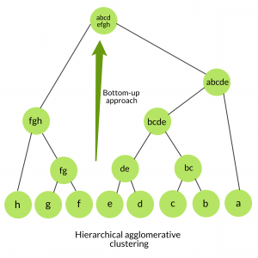
2.Divisive clustering : Also known as top-down approach. This algorithm also does not require to prespecify the number of clusters. Top-down clustering requires a method for splitting a cluster that contains the whole data and proceeds by splitting clusters recursively until individual data have been splitted into singleton cluster.
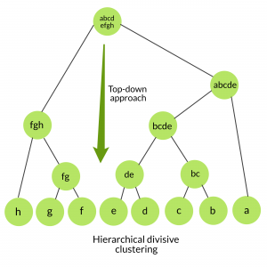

Agglomerative vs Divisive clustering –
- Divisive clustering is more complex as compared to agglomerative clustering, as in case of divisive clustering we need a flat clustering method as “subroutine” to split each cluster until we have each data having its own singleton cluster.
- Divisive clustering is more efficient if we do not generate a complete hierarchy all the way down to individual data leaves. Time complexity of a naive agglomerative clustering is O(n³) because we exhaustively scan the N x N matrix dist_mat for the lowest distance in each of N-1 iterations. Using priority queue data structure we can reduce this complexity to O(n²logn). By using some more optimizations it can be brought down to O(n²). Whereas for divisive clustering given a fixed number of top levels, using an efficient flat algorithm like K-Means, divisive algorithms are linear in the number of patterns and clusters.
- Divisive algorithm is also more accurate. Agglomerative clustering makes decisions by considering the local patterns or neighbour points without initially taking into account the global distribution of data. These early decisions cannot be undone. whereas divisive clustering takes into consideration the global distribution of data when making top-level partitioning decisions.

Clustering Large Databases:
The clustering algorithms presented in the preceding sections are some of the classic clustering techniques. When clustering is used with dynamic databases, these algorithms may not be appropriate. In addition, performing 1/0s continuously through the multiple iterations of an algorithm is too expensive. Because of these main memory restrictions, the algorithms do not scale up to large databases. Another issue is that some assume that the data are present all at once. These techniques are not appropriate for dynamic databases. Clustering techniques should be able to adapt as the database changes.

To perform effectively on large databases, a clustering algorithm should:
1. require no more (preferably less) than one scan of the database.
2. have the ability to provide status and "best" answer so far during the algorithm execution. This is sometimes referred to as the ability to be online.
3. be suspendable, stoppable, and resumable.
4. be able to update the results incrementally as data are added or removed from the database.
5. work with limited main memory.
6. be capable of performing different techniques for scanning the database. This may include sampling.
7. process each tuple only once.

Recent research at Microsoft has examined how to efficiently perform the clustering algorithms with large databases [BFR98]. The basic idea of this scaling approach is as follows:
1. Read a subset of the database into main memory.
2. Apply clustering technique to data in memory.
3. Combine results with those from prior samples.
4. The in-memory data are then divided into three different types: those items that will always be needed even when the next sample is brought in, those that can be discarded with appropriate updates to data being kept in order to answer the problem, and those that will be saved in a compressed format. Based on the type, each data item is then kept, deleted, or compressed in memory.
5. If termination criteria are not met, then repeat from step 1.

This approach has been applied to the K-means algorithm and has been shown to be effective.

BIRCH - Balanced Iterative Reducing and Clustering using Hierarchies
BIRCH is designed for clustering a large amount of numeric data. It assumes that there may be a limited amount of main memory and achieves a linear 1/0 time requiring only one database scan. It is incremental and hierarchical, and it uses an outlier handling technique. Here points that are found in sparsely populated areas are removed. The basic idea of the algorithm is that a tree is built that captures needed information to perform clustering. The clustering is then performed on the tree itself, where labelings of nodes in the tree contain the needed information to calculate distance values. A major characteristic of the BIRCH algorithm is the use of the Clustering Feature(CF), which is a triple that contains information about a cluster. The clustering feature provides a summary of the information about one cluster. By this definition it is clear that BIRCH applies only to numeric data. This algorithm uses a tree called a CF tree .

A clustering feature (CF) is a triple (N, LS, SS), where the number of the points in the cluster is N, LS is the sum of the points in the cluster, and SS is the sum of the squares of the points in the cluster.

A CF tree is a balanced tree with a branching factor (maximum number of children a node may have) B. Each internal node contains a CF triple for each of its children. Each leaf node also represents a cluster and contains a CF entry for each subcluster in it. A subcluster in a leaf node must have a diameter no greater than a given threshold value T.

Summarizing a cluster using the clustering feature can avoid storing the detailed information about individual objects or points. Instead, we only need a constant size of space to store the clustering feature. This is the key to BIRCH efficiency in space.
Moreover, clustering features are additive. That is, for two disjoint clusters, C1 and C2, with the clustering features CF1 = {n1,LS1,SS1} and CF2 = {n2,LS2,SS2}, respectively, the clustering feature for the cluster that formed by merging C1 and C2 is simply
CF1 +CF2 = {n1 +n2,LS1 +LS2,SS1 +SS2}

A CF-tree is a height-balanced tree that stores the clustering features for a hierarchical clustering.

one or more additional scans can optionally be used to further improve the quality. The
primary phases are
Phase 1: BIRCH scans the database to build an initial in-memory CF-tree, which can be viewed as a multilevel compression of the data that tries to preserve the data’s inherent clustering structure.

Phase 2: BIRCH applies a (selected) clustering algorithm to cluster the leaf nodes of the CF-tree, which removes sparse clusters as outliers and groups dense clusters into larger ones.

For Phase 1, the CF-tree is built dynamically as objects are inserted. Thus, the method is incremental. An object is inserted into the closest leaf entry (subcluster). If the diameter of the subcluster stored in the leaf node after insertion is larger than the threshold value, then the leaf node and possibly other nodes are split. After the insertion of the new object, information about the object is passed toward the root of the tree. The size of the CF-tree can be changed by modifying the threshold. If the size of the memory that is needed for storing the CF-tree is larger than the size of the main memory, then a larger threshold value can be specified and the CF-tree is rebuilt.

The rebuild process is performed by building a new tree from the leaf nodes of the old tree. Thus, the process of rebuilding the tree is done without the necessity of rereading all the objects or points. This is similar to the insertion and node split in the construction of B+-trees. Therefore, for building the tree, data has to be read just once.

Once the CF-tree is built, any clustering algorithm, such as a typical partitioning algorithm, can be used with the CF-tree in Phase 2.

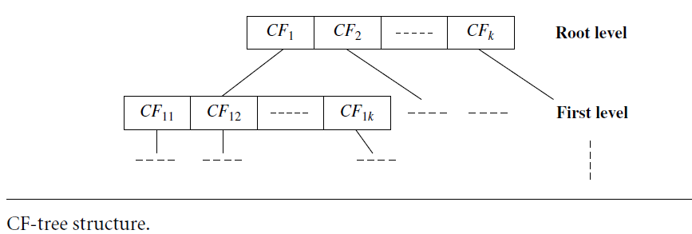

Example:

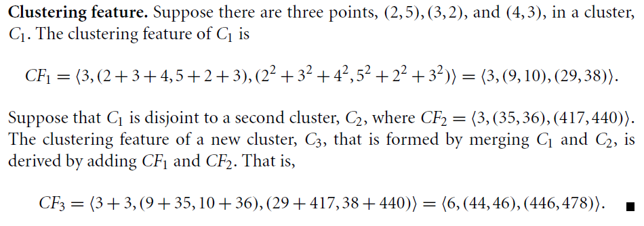

DBSCAN-Density-Based Spatial Clustering of Applications with Noise
The density of an object O can be measured by the number of objects close to O. DBSCAN finds core objects, that is, objects that have dense neighborhoods. It connects core objects and their neighborhoods to form dense regions as clusters.

A user-specified parameter > 0 is used to specify the radius of a neighborhood we consider for every object.
The -neighborhood of an object o is the space within a radius centered at o.Due to the fixed neighborhood size parameterized by , the density of a neighbourhood can be measured simply by the number of objects in the neighborhood. To determine whether a neighborhood is dense or not, DBSCAN uses another user-specified parameter, MinPts, which specifies the density threshold of dense regions. An object is
a core object if the _neighborhood of the object contains at least MinPts objects. Core objects are the pillars of dense regions.
Given a set, D, of objects, we can identify all core objects with respect to the given parameters, and. The clustering task is therein reduced to using core objects and their MinPts neighborhoods to form dense regions, where the dense regions are clusters.
For a core object q and an object p, we say that p is directly density-reachable from q (with respect to and MinPts) if p is within the -neighborhood of q. Clearly, an object p is directly density-reachable from another object q if and only if q is a core object and p is in the -neighborhood of q. Using the directly density-reachable relation, a core object can “bring” all objects from its -neighborhood into a dense region.
“How can we assemble a large dense region using small dense regions centered by core objects?” In DBSCAN, p is density-reachable from q (with respect to and MinPts in D) if there is a chain of objects p1, : : : ,pn, such that p1 = q, pn = p, and pi+1 is directly density-reachable from pi with respect to and MinPts, for 1 <= I <=n, pi belongs to D. Note that density-reachability is not an equivalence relation because it is not symmetric. If both o1
and o2 are core objects and o1 is density-reachable from o2, then o2 is density-reachable from o1. However, if o2 is a core object but o1 is not, then o1 may be density-reachable from o2, but not vice versa.

To connect core objects as well as their neighbors in a dense region, DBSCAN uses the notion of density-connectedness. Two objects p1,p2 2 D are density-connected with respect to and MinPts if there is an object q belongs to D such that both p1 and p2 are density reachable from q with respect to and MinPts. Unlike density-reachability, density connectedness is an equivalence relation. It is easy to show that, for objects o1, o2, and o3, if o1 and o2 are density-connected, and o2 and o3 are density-connected, then so are o1 and o3.

Example: Refer to Data Mining by Kamber Text book, Pg No:472

